

ATAR Physics

Year 12 2019

**Task 7: Topic Test 3**

**Wave Particle Duality and Quantum Theory**

Student Name: _______________________________

Weighting: 10%

I acknowledge that all the information contained in this task is my own work and not taken from other sources. If other sources have been used they have been acknowledged in my references.

____________________________________

(Student Signature)

Teacher Comments:

**Time allowed**: 60 minutes + 3 mins reading time.

|  |  |  |  |  |
| --- | --- | --- | --- | --- |
| **Section** | Number of questions | Your Mark | Marks available | Percentage of Test |
| **Section One:**  Short answer | 4 |  | 18 | 30 |
| **Section Two**:  Extended answer | 3 |  | 33 | 55 |
| **Section Three:**  Comprehension  and data analysis | 1 |  | 9 | 15 |
|  | **Total** |  | **60** | **100** |

Please do not turn the page until instructed to do so

**Section One:** Short answer

**Question 1**

Which one of the following statements about the photoelectric effect is correct?

1. The kinetic energy of electrons ejected from a metal surface will increase as the intensity of light incident on the surface is increased.
2. The minimum energy of a photon needed to eject an electron from a metal surface varies with the frequency of the incident light.
3. For light above the required minimum frequency, an increase in the intensity of the incident light on a metal surface will increase the number of electrons ejected from its surface.
4. The photoelectric effect is used as evidence to support the model of light as a transverse electromagnetic wave.

Explain why you think the answer you have chosen is correct.

|  |
| --- |
|  |
|  |
|  |
|  |
|  |

[3 Marks]

**Question 2**

Ultraviolet light with a frequency of 1.46 × 1015 Hz is shone onto the surface of an unknown element. Electrons with a kinetic energy of 1.22 eV are measured being emitted from the surface of the element. From the list of elements below, identify which is the unknown element. Show clear working to support your answer.

|  |  |
| --- | --- |
| **Element** | **Work function (eV)** |
| aluminium | 4.08 |
| beryllium | 5.00 |
| boron | 4.45 |
| carbon | 4.81 |
| gallium | 4.32 |
| manganese | 4.10 |

[5 Marks]

**Question 3**

If a beam of white light is shone through a sample of oxygen gas as illustrated below and the emergent light examined through a spectroscope, what type of spectrum would you expect to see on the other side. Explain why this is produced.

|  |
| --- |
|  |
|  |
|  |
|  |
|  |

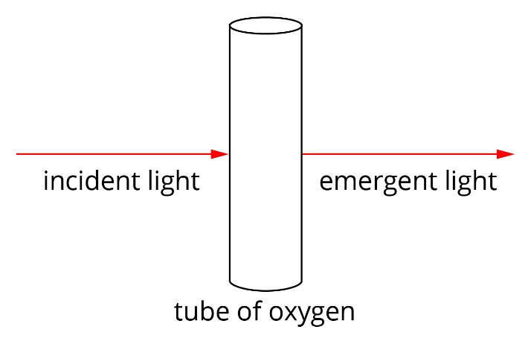

|  |
| --- |
|  |
|  |

[3 Marks]

**Question 4**

The diagram below shows some of the energy levels for a mercury atom.

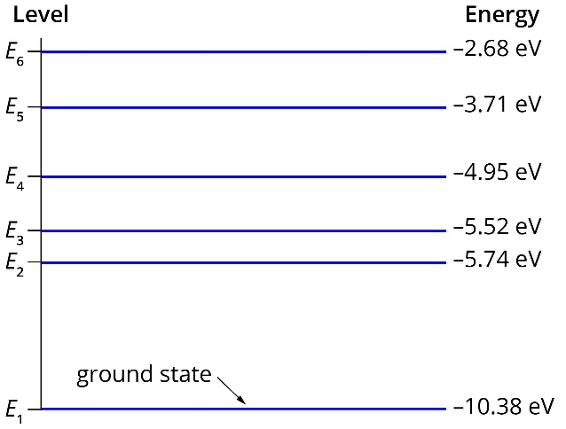

1. The line emission spectrum for mercury has a prominent blue line at about 437 nm. Determine between which two energy levels an excited electron will transition to emit light of this wavelength.

[4 Marks]

1. How much energy would be required to cause ionisation of electrons from mercury atoms? Explain how you determined this value.

|  |
| --- |
|  |
|  |
|  |
|  |

[3 Marks]

**Question 5**

In an experiment, Helen shines a red light onto a piece of cardboard that has two small slits cut into it. She notices a pattern of lines on the screen behind the piece of cardboard, as shown in the diagram below.



Explain why Helen sees a pattern of lines on the screen and why this experiment is considered to be evidence for the wave nature of light.

|  |
| --- |
|  |
|  |
|  |
|  |

[3 Marks]

**Section Two:** Extended answer

**Question 6 [8 Marks]**

A red and a blue laser are both rated at 10 W. A spectroscopic detection device determines that the two lasers produce wavelengths of 460 nm and 670 nm.

1. What does the acronym L.A.S.E.R stand for?

[1 Mark]

1. Which wavelength matches each colour? Provide logical reasoning for your answer.

|  |
| --- |
|  |
|  |

[3 Marks]

1. Calculate the number of photons of the 460 nm radiation which would be produced in a minute.

[2 Marks]

1. How would this number compare to the number produced of the 670 nm photons. Give reasoning for your answer. (no calculation is required)

|  |
| --- |
|  |
|  |
|  |

[2 Marks]

**Question 7**  **[11 Marks]**

Cancerous cells have often experienced a mutation (chemical change) to their genetic material

(DNA) and, as a result, these cells multiply at a greater rate than normal cells. Chemical changes to sections of DNA molecules result if photons of electromagnetic radiation ionise atoms within the DNA molecules. Evidence suggests that the minimum energy required to ionise any section of DNA is about 32 eV.

1. What wavelength of photons would a person need to be exposed to in order to cause damage to cells by ionisation?

[2 Marks]

1. Do X-rays have the required properties to damage cells through ionisation? Explain.

|  |
| --- |
|  |
|  |

[2 Marks]

1. When atoms absorb photons with energies less than their ionisation energies, they may be excited to higher energy states. They only absorb photons of specific energies however. Explain why.

|  |
| --- |
|  |
|  |

[2 Marks]

1. If a photon has more than the required energy for ionisation, what happens to the

excess energy?

|  |
| --- |
|  |

[1 Mark]

1. Some minerals fluoresce red when X-rays are shone onto them. Explain how this occurs.

|  |
| --- |
|  |
|  |
|  |
|  |
|  |
|  |
|  |
|  |

[4 Marks]

**Question 8**  [11 Marks]

1. Louis de Broglie was a French physicist who made very significant contributions to quantum theory. In his 1924 he proposed his most famous and ground-breaking hypothesis which suggested what?

|  |
| --- |
|  |
|  |
|  |
|  |

[2 Marks]

1. What characteristic behaviour was first observed in 1927 to confirm Louis de Broglie’s hypothesis?

[1 Mark]

1. Imagine a 2.30 gram caterpillar crawling along a leaf at 0.470 cm/s. Calculate the caterpillar's de Broglie wavelength during its crawl.

[3 Marks]

1. At what speed would an electron have to be moving a de Broglie wavelength of 490 nm?

[2 Marks]

1. Which of the two examples above could most likely be used in an experiment to confirm Louis de Broglie’s hypothesis? Explain your answer.

|  |
| --- |
|  |
|  |
|  |
|  |

[3 Marks]

**Section Three:** Comprehension and data analysis

**Question 9** [9 Marks]

Some students were conducting an experiment using the activation voltages of four L.E.D’s to determine an experimental value for Planck’s constant. The activation voltage is the minimum voltage required for electrons to jump and join with a positively charged atom or “hole”. As the electrons return to ground state they release a photon of light that is dependent on the characteristics of the metal “hole” atoms they combine with. In the process work is done on the electron, which is of course related to the potential difference crossed.

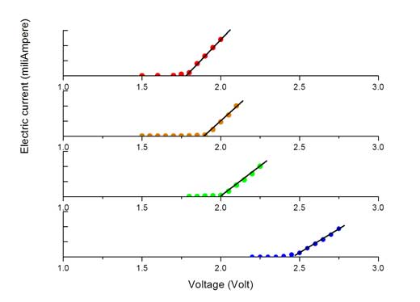

Red

Yellow

Green

Blue

To determine the activation voltage of each L.E.D., the students slowly increased the voltage and measured the current that flowed through it. At voltages lower than the activation voltage, no current or light was observed as shown in the graphs to the right.

1. Using equations from your formulae and constants sheet write an equation which links the activation voltage with the photon energy released by the L.E.D.

[1 Mark]

1. Explain why the activation voltages for each colour are different.

|  |
| --- |
|  |
|  |
|  |

[3 Marks]

1. Using the activation voltage, the energy of each photon could be calculated. After averaging the results of five groups together, the following data was compared to the manufacturer provided frequency for each L.E.D. Plot these on the axes provided below.

|  |  |  |  |
| --- | --- | --- | --- |
| LED Colour | Average Activation Voltage (Vs) | Manufacturer stated Frequency x 1014 (Hz) | Photon Energy x 10-19 (J) |
| red | 1.27 | 4.54545 | 2.03 |
| orange | 1.40 | 4.91803 | 2.24 |
| yellow | 1.41 | 5.08475 | 2.26 |
| green | 1.75 | 5.82524 | 2.80 |
| blue | 2.05 | 6.45161 | 3.28 |

[1 Mark]

1. Use the graph to determine the experimental value for Planck’s constant. All logic should be clearly set out.

[4 Marks]